***[Secure Web Application for Online Marketplace](http://1000projects.org/secure-web-application-for-online-marketplace.html)***

**Abstract:**

This Application allows the customers or users to find an easy way for service providers around their locality. Admin will add the categories and features of particular product or service. He will add service providers too based on the prominent locations around the city. Users will register and send the queries or service requests according to the services provided by the admin. the queries will be forwarded to the service provider and the service provider will try to solve by online. If the user is not satisfied with the service provider solution, he can send the feedback to admin and admin can block the service provider.

This Online Marketplace application has enhanced matching of user location and registered serviced provider location.

**Existing System:**

In the Existing Online Marketplace System, the user or customer has to visit service centers provided by the companies and he has to search his nearby Location and the response from the service provider may not be satisfactory to the user so in that user cannot complain or they cannot give their opinions and feedback.

**Proposed System:**

In The Propose System, user or customer need not visit the service center they simply can register into the application by giving their location. It is as simple as that the added service providers in that location will receive the user queries whenever the user sends it. Thereafter he can respond over to the user and if the response is not satisfactory he can give the feedback to the admin

**Softwares used to develop this wedding Event application below:**

Netbeans 8.0.1, JDK 1.7, MySQL 5.5, SQLYog, HTML, JavaScript and CSS.

**UML Diagrams:**

[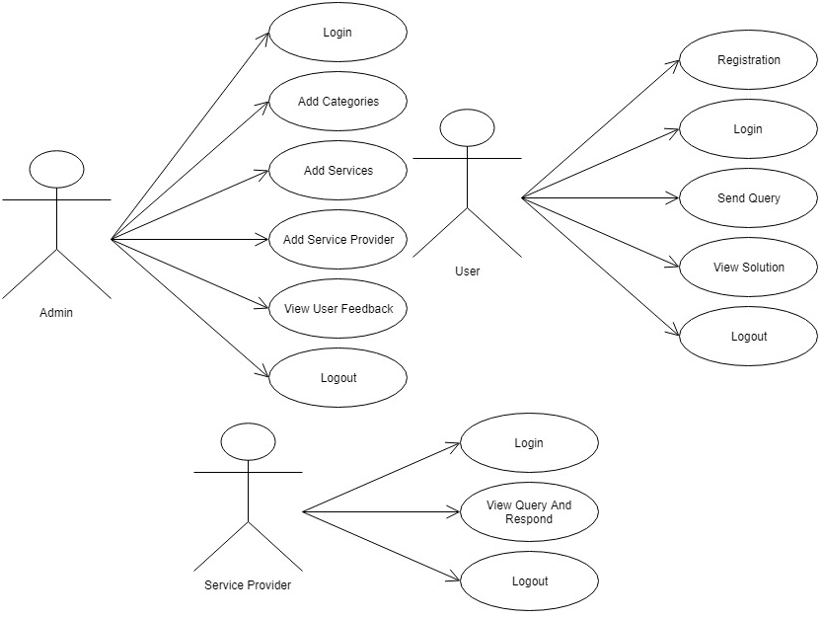](http://1000projects.org/wp-content/uploads/2018/04/Use-Case-Diagram-Online-Marketplace.png)

**Sequence Diagrams**

[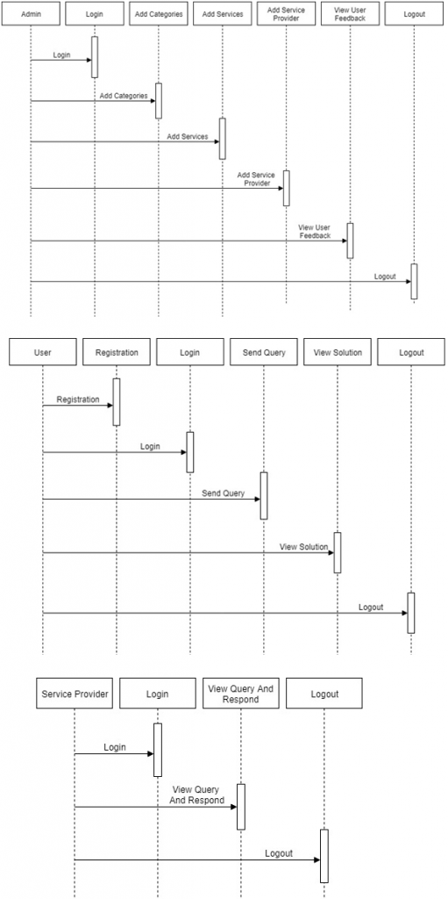](http://1000projects.org/wp-content/uploads/2018/04/Sequence-Diagram-Online-Marketplace.png)

**Activity Diagram:**

[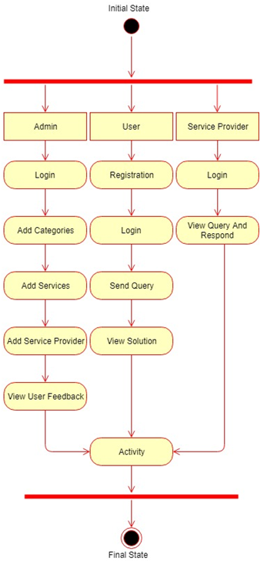](http://1000projects.org/wp-content/uploads/2018/04/Activity-Diagram-Online-Marketplace.png)

**Class Diagram:**

[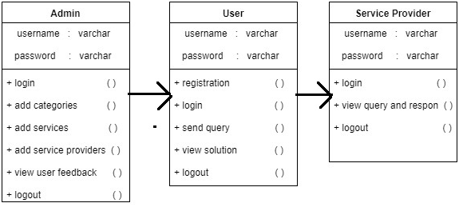](http://1000projects.org/wp-content/uploads/2018/04/Class-Diagram-Online-Marketplace.png)

The Modules Embedded in the application is

* USER
* ADMIN
* SERVICE PROVIDER

**Modules**

**Admin**

Admin login with the valid username and password and after that he can add Categories, Products, Service providers. While Adding service providers the admin must give the location of the service providers and admin can also have the access to view the feedback from the user about service provider and he can also block him.

**User**

The user must be registered and log in, after logging in the user will select the category and the service required while sending the query the user needs to provide the location, Based on the location the service provider can the user query. After the query is sent the user will wait for the service provider solution and if he satisfies that is okay if not he can give feedback to admin.

**Service Provider**

The service provider will log in and the view the user queries or requests based on his location and he responds and provide a solution user.